GPI Data Analytics Project
Absence of Insights for the Relationship Between Student's Economic Background,
Academic Performance, Competence & Expected Salary
Dataset: Power_BI_Updated_Data_analyst_Data.xlsx | Tool: Python (Pandas, Matplotlib)
Cloud Counselage • Global Professional Internship • Data Analytics

Swayam Ballal
IP-11654
BASIC QUESTIONS (Q1 – Q9)
Q1. How many unique students are included in the dataset?
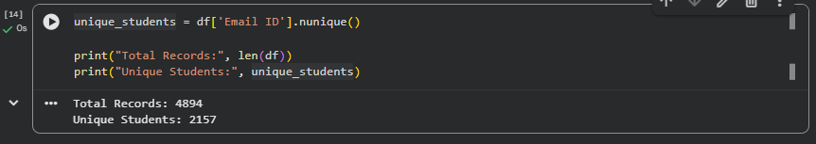
Conclusion: The dataset contains 4,894 total event registrations, but only 2,157 unique students (identified by Email ID). This means many students attended multiple events — each row represents one event registration, not one unique student.

Q2. What is the average GPA of the students?
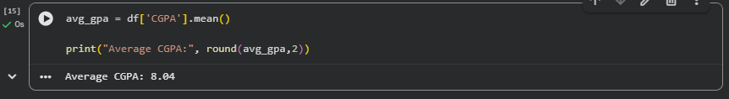
Conclusion: The average GPA (CGPA) of all students in the dataset is 8.04. This indicates that the student cohort is academically above-average, as most values cluster between 7 and 9.

Q3. What is the distribution of students across different graduation years?
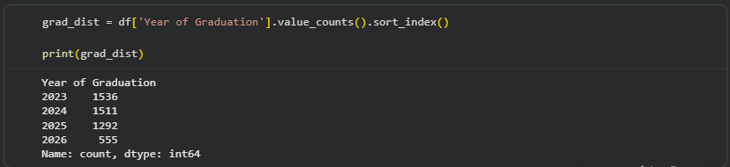
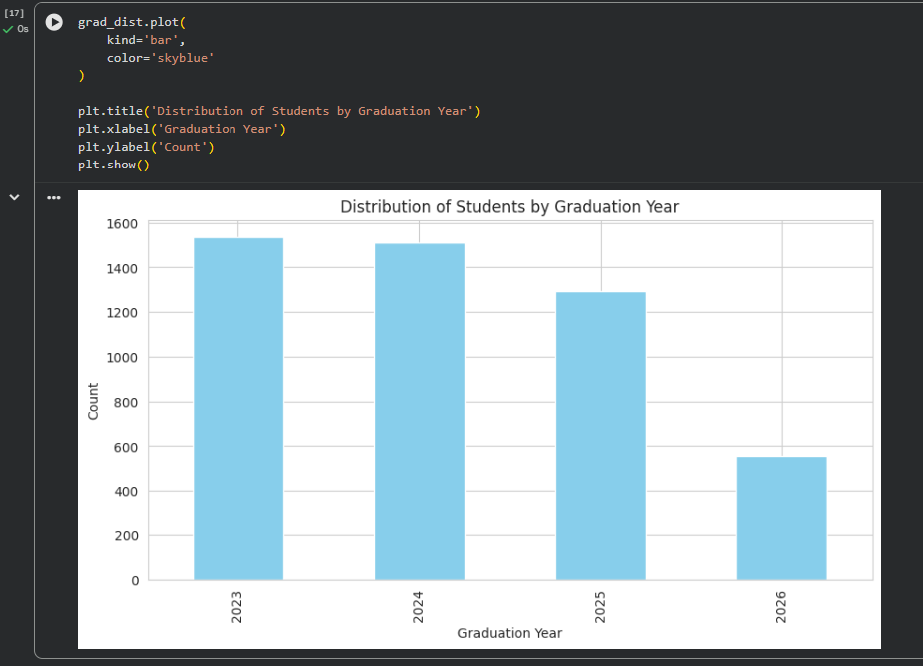
Conclusion: Students are spread across 4 graduation years: 2023 (1,536), 2024 (1,511), 2025 (1,292), and 2026 (555). The majority of participants are final-year or recently graduated students (2023–2024), suggesting the events attract job-ready students actively upskilling.

Q4. What is the distribution of student's experience with Python programming?
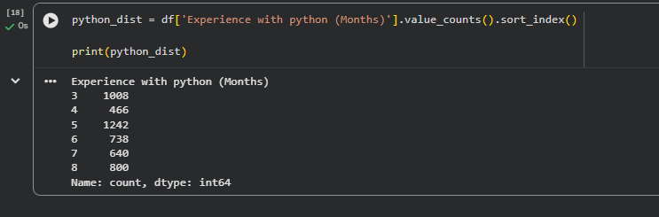
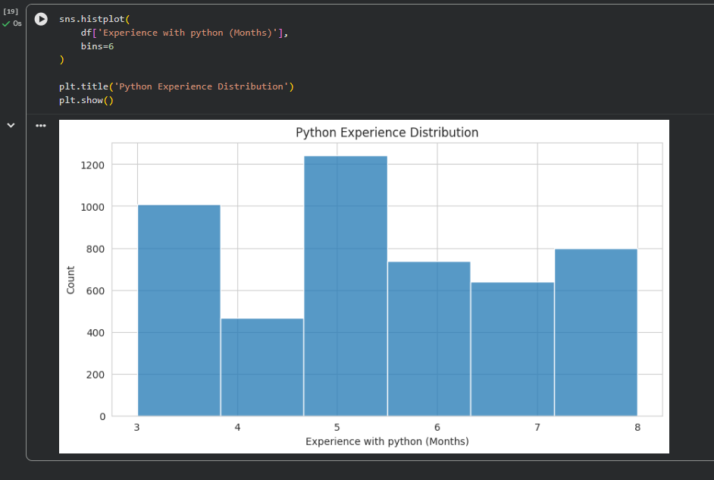
Conclusion: Python experience ranges from 3 to 8 months. The most common is 5 months (1,242 students), followed by 3 months (1,008) and 8 months (800). This bimodal pattern suggests two groups — beginners (3 months) and intermediate learners (5–8 months).

Q5. What is the average family income of the student?
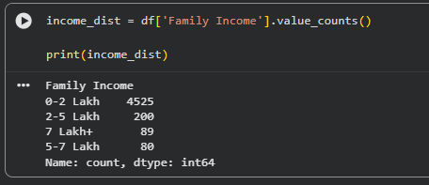
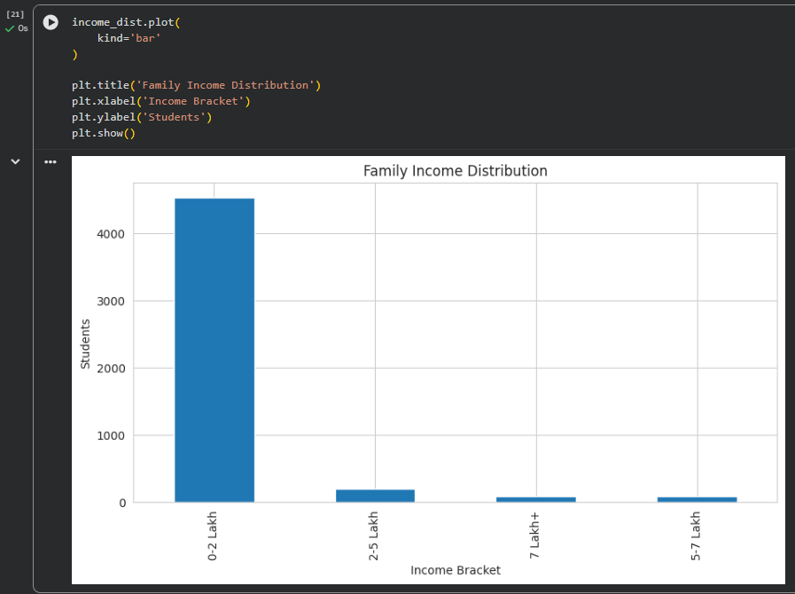
Conclusion: Family income is a categorical variable. An overwhelming 92.5% of students (4,525 out of 4,894) fall in the 0–2 Lakh bracket, followed by 2–5 Lakh (4.1%), 7 Lakh+ (1.8%), and 5–7 Lakh (1.6%). This shows the platform predominantly serves students from economically weaker backgrounds.

Q6. How does the GPA vary among different colleges? (Show top 5 results only)
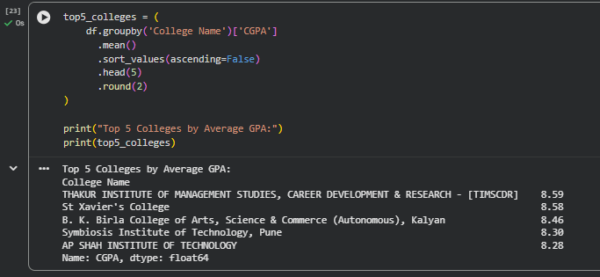
Conclusion: TIMSCDR (8.59) and St. Xavier's College (8.58) have the highest average GPAs, followed by BK Birla Kalyan (8.46), Symbiosis Pune (8.30), and AP Shah (8.28). These colleges attract students with stronger academic profiles compared to the dataset average of 8.04.

Q7. Are there any outliers in the quantity (number of courses completed) attribute?
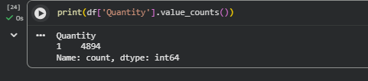
Conclusion: No outliers are present in the Quantity (number of courses completed) attribute. All 4,894 records have a Quantity value of 1, indicating that each registration corresponds to exactly one event participation. Since the variable has no variation, outlier detection is not applicable.

Q8. What is the average GPA for students from each city?
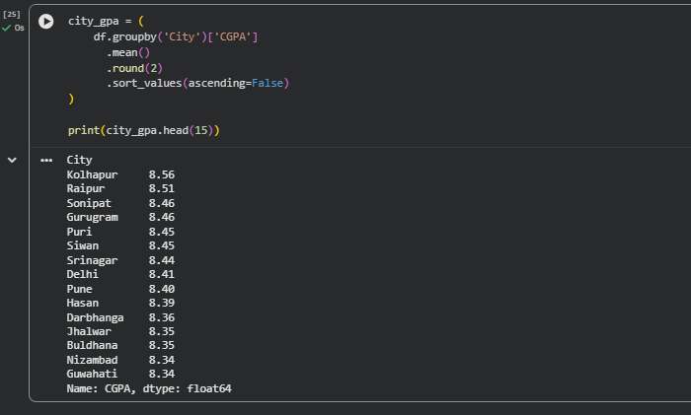
Conclusion: The highest average CGPA was observed in Kolhapur (8.56), followed by Raipur (8.51), Sonipat (8.46), Gurugram (8.46), and Puri (8.45). Although some cities demonstrate slightly stronger academic performance, the overall variation in average CGPA across cities is relatively small, suggesting fairly consistent academic performance among students from different locations.

Q9. Can we identify any relationship between family income and GPA?
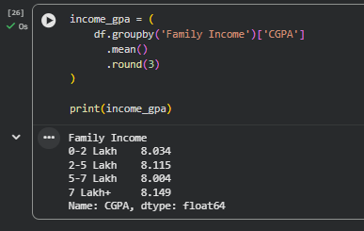
Conclusion: There is a very weak positive relationship between family income and GPA. Students from higher income brackets (7 Lakh+) have a slightly higher avg GPA (8.149) vs. the lowest bracket (0–2 Lakh) at 8.034. However, the difference is minimal (~0.1), suggesting family income has little practical impact on academic performance in this dataset.

MODERATE QUESTIONS (Q10 – Q17)
Q10. How many students from various cities? (Solve using data visualisation tool)
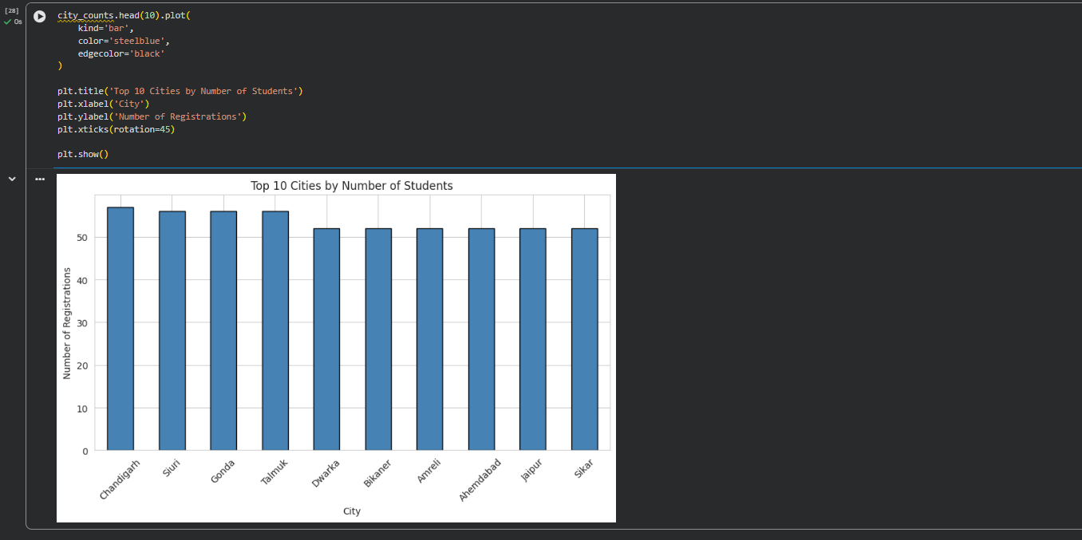
Conclusion: Chandigarh leads with 57 students, followed closely by Gonda, Siuri, and Talmuk (56 each), and then Ahmedabad, Amreli, Dwarka, Bikaner, Jaipur, and Jhalwar (52 each). The student base is geographically diverse and spread across Tier 1, 2, and 3 cities of India.

Q11. How does the expected salary vary based on factors like 'GPA', 'Family income', 'Experience with python (Months)'?
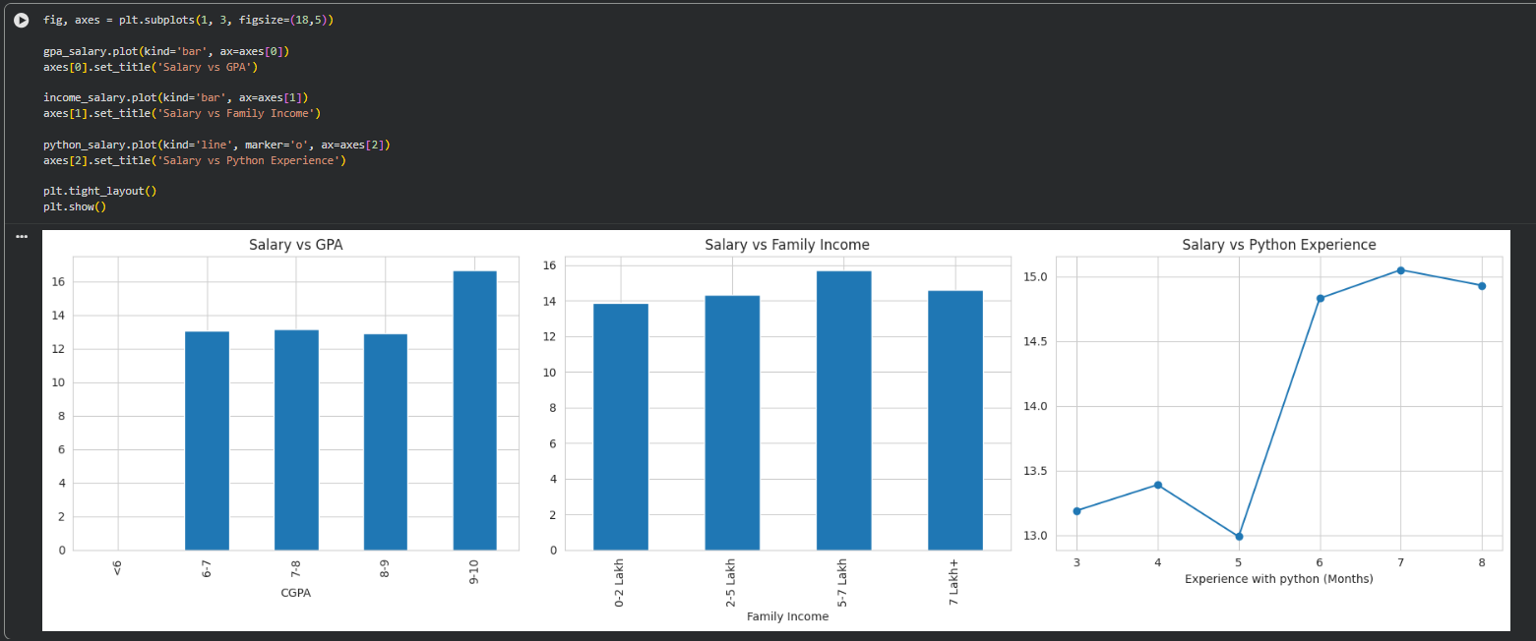
Conclusion: Students with GPA 9-10 expect significantly higher salary (₹16.65L) vs others (₹13L avg). Higher family income also correlates with higher salary expectations (5-7L bracket: ₹15.69L). Python experience above 6 months pushes expectations to ₹14.8-15L vs ₹13L for 3-5 months. All three factors positively influence salary expectations.

Q12. Which event tends to attract more students from specific fields of study?
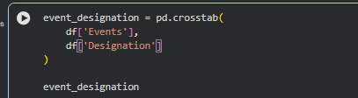
Conclusion: Event participation varies across different fields and designations. Most events were primarily attended by students, with Product Design & Full Stack attracting the highest participation (842 students), followed by Internship Program (IP) Success Conclave (545 students). The Internship Program Success Conclave demonstrated the most diverse audience, attracting participants from multiple professional and academic backgrounds such as Artificial Intelligence, Software Engineering, Research Scholars, Professors, and Recruitment Managers. This indicates that career-oriented events tend to appeal to a broader range of participants compared to specialized technical events.

Q13. Do students in leadership positions tend to have higher GPAs or better expected salary?
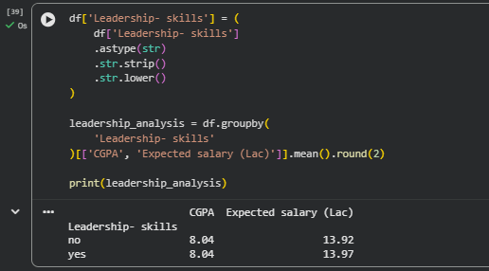
Conclusion: Leadership skills show no significant impact on academic performance or expected salary. Students with leadership skills and those without leadership skills have the same average CGPA (8.04) and nearly identical salary expectations (13.97 LPA vs 13.92 LPA). This suggests that leadership experience alone is not a major factor influencing academic success or salary expectations within this dataset.

Q14. How many students are graduating by the end of 2024?
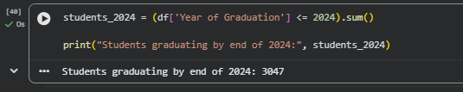
Conclusion: A total of 3,047 students are expected to graduate by the end of 2024. This represents a significant portion of the dataset and indicates a large pool of students entering the job market or pursuing higher education opportunities in the near future.

Q15. Which promotion channel brings in more student participations for the event?
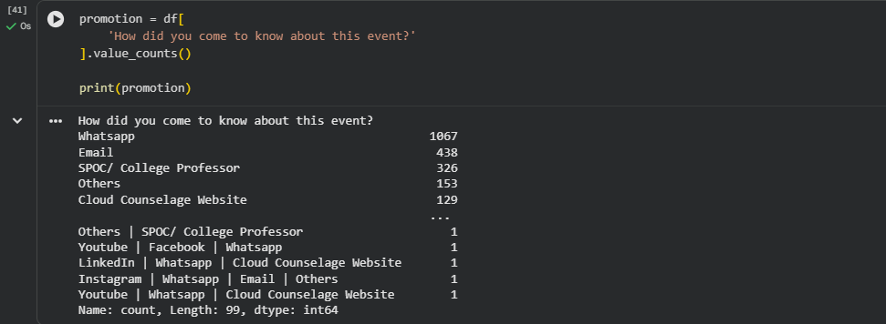
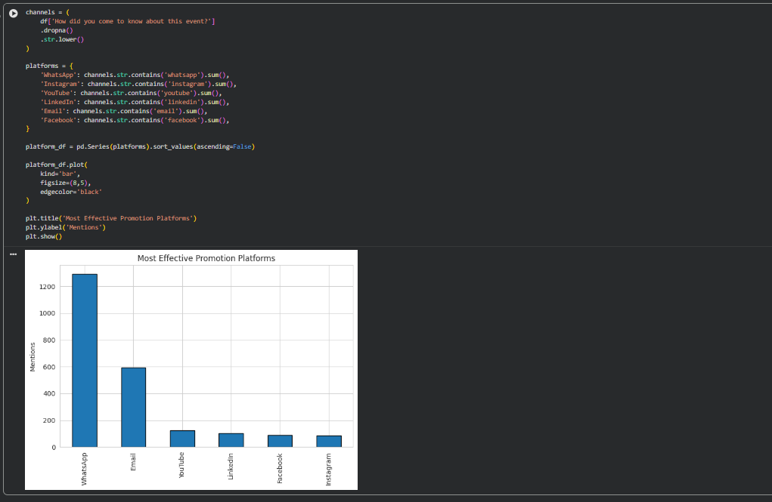
Conclusion: WhatsApp is the dominant promotion channel with 1,067 registrations (21.8%), followed by Email (438, 8.9%) and SPOC/College Professor (326, 6.7%). This strongly suggests that WhatsApp-based outreach is the most effective channel for student engagement and should be the primary marketing focus.

Q16. Find the total number of students who attended the events related to Data Science? (From all Data Science related courses)
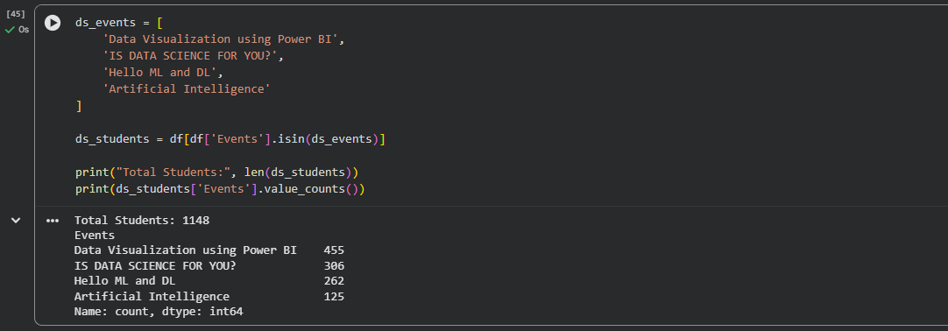
Conclusion: A total of 1,148 students participated in Data Science and Artificial Intelligence related events. The most popular event was Data Visualization using Power BI (455 participants), followed by IS DATA SCIENCE FOR YOU? (306 participants), Hello ML and DL (262 participants), and Artificial Intelligence (125 participants). These participation numbers indicate strong student interest in Data Science, Machine Learning, Artificial Intelligence, and Analytics-related career paths.

Q17. Do students with higher CGPA and greater Python programming experience have higher expected salary expectations?
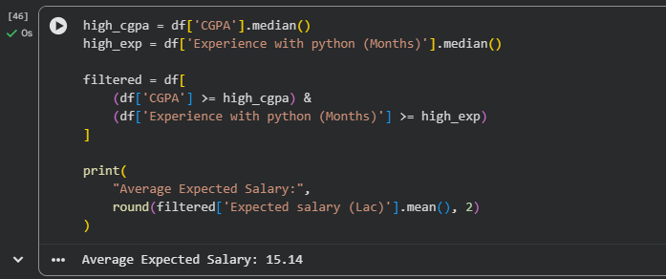
Conclusion: Students with above-median CGPA and above-median Python programming experience have an average expected salary of 15.14 LPA. This value is higher than the overall average expected salary observed in the dataset, indicating that a combination of strong academic performance and technical competence positively influences salary expectations. The result suggests that students who excel both academically and technically tend to have greater confidence in their future earning potential.

